Multiple choice section

Question 1 [6.1]

Which of the following is the same as 85 cm?

A 850 m B 8.5 km C 8.5 mm D 850 mm

Question 2 [6.2]

The perimeter of a rectangle of length 7 cm and width 60 mm is:

A 26 cm B 42 mm C 42 cm D 270 mm

Question 3 [6.6]

Assuming that each cube represents 1 cm3, the volume of the following object in cm3 is:

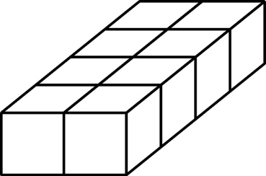

A 8 cm3 B 4 cm3 C 10 cm3 D 12 cm3

Question 4 [6.3]

A square of area 36 m2 has side length:

A 2 m B 6 m C 18 m D 9 m

Question 5 [6.1]

Which metric unit would be most appropriate for measuring the distance from  
Brisbane to Adelaide?

A metres B kilometres C centimetres D millimetres

Question 6 [6.1]

Which set of lengths are in ascending order?

A 4.4 m, 400 cm, 4 km, 40 m

B 40 m, 400 cm, 4.4 m, 4 km

C 400 cm, 4.4 m, 40 m, 4 km

D 4 km, 4.4 m, 400 cm, 40 m

Question 7 [6.3]

Which metric unit would be most suitable for measuring the area of a 50 cent coin?

A mm2 B litres2 C m2 D km2

Question 8 [6.3]

Assume the shape has been drawn on centimetre grid paper. Estimate its area.

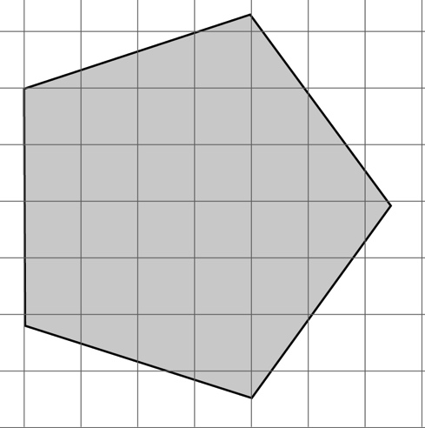

A 7 cm2 B 15 cm2 C 30 cm2 D 36 cm2

Question 9 [6.4]

A parallelogram with a base of 12 cm, and a height of 3 cm has an area of:

A 30 cm2 B 36 cm2 C 3.6 cm2 D 24 cm2

Multiple-choice total marks: ____ / 9

Short answer section

Question 10 3 marks [6.2, 6.5, 6.6]

Use words from the list below to complete the following sentences.

base perpendicular distance half length breadth

(a) The area of a triangle is equal to half of the product of the base and the ____________________ height.

(b) The perimeter is the ____________________ along the boundary of a shape.

(c) The volume of a rectangular prism is the product of its ____________, width and height.

Question 11 3 marks [6.1]

Complete the following conversions.

(a) 8 km = __________ m (b) 456 mm = _________ cm (c) 152 mm = __________ m

Question 12 2 marks [6.1]

The tallest living person is 246.5 cm and the shortest person is 59.93 cm. Convert these dimensions to metres, rounded to 2 decimal places.

Question 13 2 marks [6.1]

Shirley is knitting a scarf. If, at the end of Monday the scarf is 180 mm long and she can knit 25 cm in a day, how long is the scarf at the end of Saturday (in centimetres)?

Question 14 4 marks [6.2]

Draw a diagram and then find the perimeter of:

(a) a rectangle with a length of 22 cm and a width of 84 mm

(b) a square with side lengths of 360 mm.

Question 15 2 marks [6.2]

Find the perimeter of the following shape.

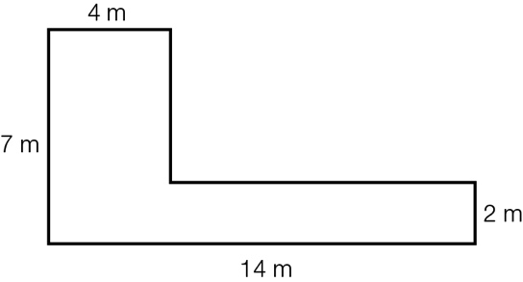

Question 16 3 marks [6.3]

Jim has a rectangular backyard. In the middle of his yard is a deck measuring 8 m by 6 m, which is surrounded by a 1 m wide path and then a garden 2 m wide around the path. What is the total area of Jim’s backyard?

Question 17 4 marks [6.3]

Find the area of the following.

(a) A square with side lengths of 2.8 cm.

(b) A rectangle with a length of 4.4 cm and a width of 8 cm.

Question 18 3 marks [6.3]

A window has a height of 1.2 m and is 900 mm wide. A curtain is to be made for the window.  
If the material for the curtain needs to be three times the width of the window and have a length 30 cm longer than the window, how much material is required to make the curtain (in square metres)?

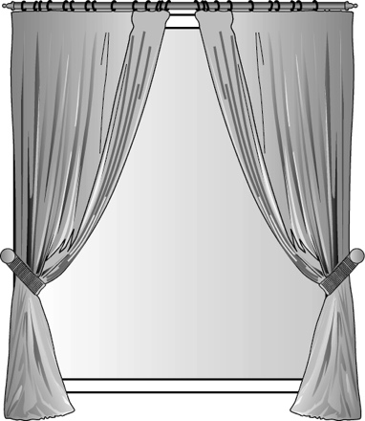

Question 19 2 marks [6.4]

Find the area of the parallelogram.

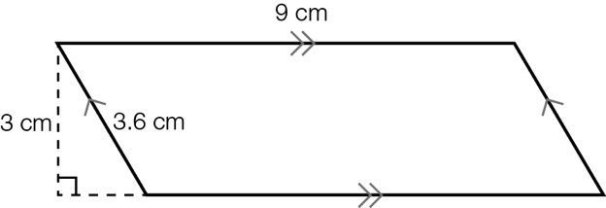

Question 20 3 marks [6.4]

A parallelogram has a base length of 9 cm and an area of 63 cm2. What is its height?

Question 21 2 marks [6.5]

Find the area of the triangle.

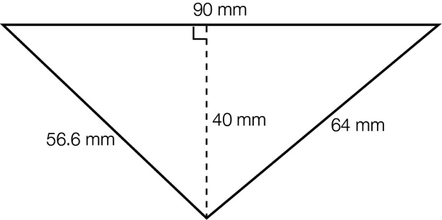

Question 22 3 marks [6.5]

Find the area of the following composite shape.

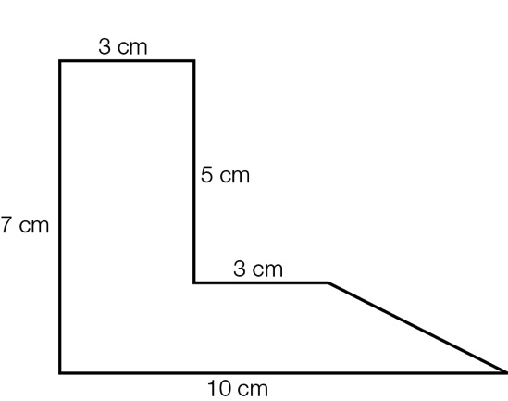

Question 23 3 marks [6.5]

Find the shaded area.

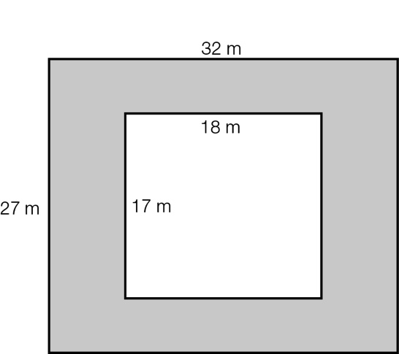

Question 24 2 marks [6.6]

Find the volume of the rectangular prism. (Each small cube represents 1 cm3.)

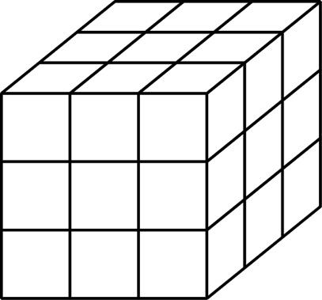

Question 25 2 marks [6.6]

Find the volume of the rectangular prism.

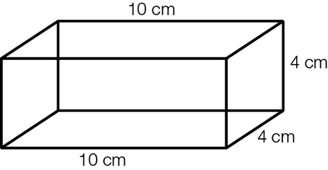

Question 26 3 marks [6.6]

A rectangular prism has a volume of 240 cm3. If its length is 8 cm and its width is 6 cm, what is its height?

Question 27 3 marks [6.5]

Karman is making a mosaic tray. If the tray measures 480 mm by 320 mm and each square tile has a side length of 2 cm, how many tiles are required to cover the tray?

Short answer total:_________/49

Extended answer section

Question 28 5 marks [6.6]

(a) A large carton contains 24 boxes of cereal. If the dimensions of a cereal box are 185 mm by 280 mm by 40 mm, find the volume of the large carton.

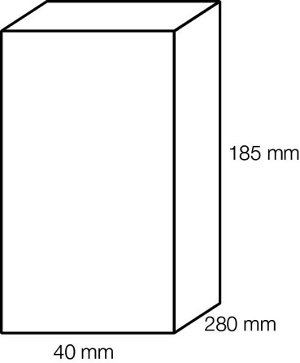

(b) If the cereal boxes are stacked two high and one wide in the carton, what are the possible dimensions of the carton (in mm2)?

Question 29 2 marks [6.2, 6.3]

The following rectangle has an area of 25 cm2 and a perimeter of 25 cm. Find another rectangle that has the same numerical value for the both its area and its perimeter.

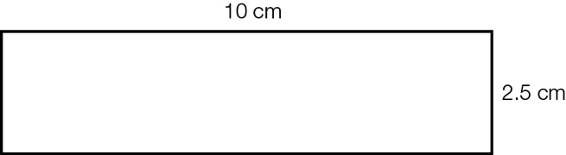

Question 30 4 marks [6.5]

Toni wants to cover a wall with some artwork. She wants to buy three canvases all of the same size. The wall is 2.4 m high and 3.1 m wide. The canvases must have a 10 cm gap between each canvas and the ends of the wall.

(a) Which canvas from the list below will be the best fit? (Toni wants to use most of the wall.)

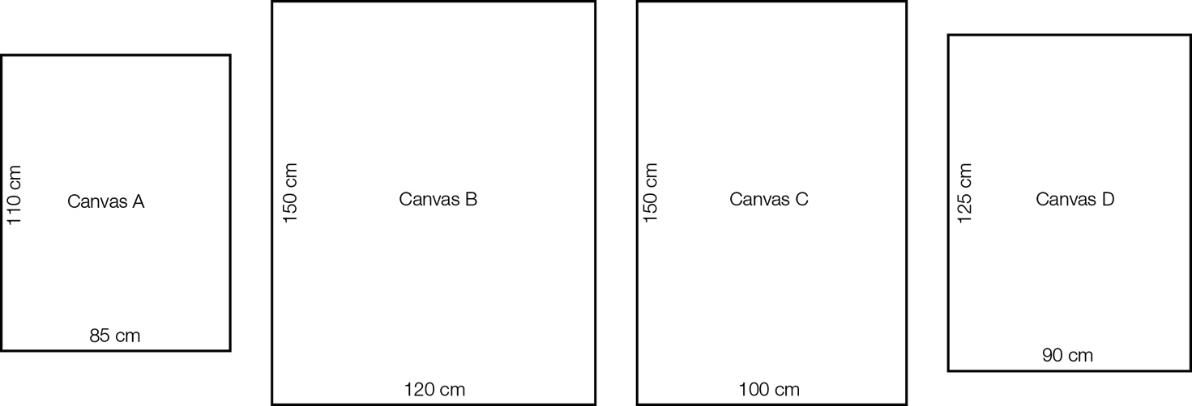

(b) What is the total area of the three canvases?

Extended answer total:_________/11

TOTAL test marks: _______ / 69